TOTHBOT — KRAKEN SYSTEM ARCHITECTURE OVERVIEW
The Complete System — All Architectural Decisions + All Flow Diagrams

DocDCN: 0500000
DocTitle: TothBot_Kraken_System_Architecture_Overview
DocVersion: dv1_14
DocOwner: Bill
DocPath: GitHub.com/TothBot/TothBot-V2-Docs/05XXXXX_System_Architecture/0500000_System_Architecture_Overview_dv1_14.docx
DocDate: 03-26-2026
DocTime: 23:59:59 UTC

PURPOSE: This document captures all architectural decisions, FP/DP analyses, and system specifications from the TothBot Kraken architecture sessions of March 2026. Includes all six system flow diagrams showing connections between Kraken, TothBot, and CIATS as one unified organism.
Diagrams in this document (dv1_14 — diagrams unchanged from dv1_10)
Diagram 1 — Kraken API Connection Architecture
(dv1_6: amend_order primary, batch_cancel, WS ping A-7, zombie A-8, balances seq A-9, per-pair status, L3 URL corrected)
(dv1_7: executions seq gap detection A-10, GetOpenOrders gap recovery)
(dv1_9: GAP-A order_status:true CRITICAL FIX, GAP-C price_increment, GAP-D qty_min/cost_min, GAP-E max_size=10MB, IMP-11 maxratecount, IMP-13 warnings[])
(dv1_10: GAP-B stp_type underscore CORRECTION, A-21 deadline parameter, IMP-16 aiohttp ClientTimeout, IMP-17 TCPConnector, IMP-18 ticker bbo)
(dv1_14: text-only — AR-057 through AR-066)
Diagram 2 — TothBot Trading Pipeline (dv1_6: per-pair instrument status check added before Gate 1)
Diagram 3 — Exit Architecture: Ground Zero Redesign (dv1_6: title updated)
Diagram 4 — Regime Taxonomy: 6-Regime Grid + Two-Level Tagging (dv1_6: title updated)
Diagram 5 — CIATS Architecture: Data Flows and Improvement Cycle (dv1_6: title updated)
Diagram 6 — Complete System: One CIATS-Owned Organism
(dv1_9: GAP-A through F, IMP-11 through 17)
(dv1_10: GAP-B stp_type correction, A-21 deadline, IMP-16/17 aiohttp, IMP-18 bbo, IMP-19 regime stagger)

1. System Identity and Mission

1.1 What TothBot Is
TothBot is an automated cryptocurrency spot trading system on Kraken exchange. It runs 24/7/365 on a Hetzner VPS, processes 5-minute OHLC candle close events as its system clock, and executes long-only trades using a momentum-based signal engine.
TothBot is not an external system connected to Kraken — it IS Kraken's event processor. Every action is a response to a Kraken push event. No timers. No polling. Idle and silent until Kraken speaks.

1.2 The One Organism Principle
Three functional zones, one organism:
Kraken: generates events, executes orders, holds resting TP limit orders and off-book emergency SL stop orders on matching engine
TothBot: processes Kraken events, executes trading strategy, manages positions
CIATS: learns from event records, continuously improves processing rules
PRIMARY MISSION: Maximize profit. Minimize loss. With an emphasis on minimizing loss. Loss prevention takes priority over profit generation. Everything else is secondary.

1.3 Operating Environment
Exchange: Kraken Spot (Long Module — Short deferred)
Language: Python 3.12.3
VPS: Hetzner CPX22 — 87.99.141.44 — Ashburn VA (Kraken Spot servers: AWS us-west-2 Oregon)
System Clock: Kraken OHLC 5-minute candle close event (WS v2 push)
Fee Baseline: Maker 0.16% / Taker 0.26% (CIATS monitors actuals)
Operation: 24/7/365 — CIATS may add stand-down periods via PDCA if data supports
Starting Portfolio: $1,000 Long Module
Sacred Constraint: Net 1:1.5 R:R — HARDCODED — the only number not owned by CIATS

2. Kraken API Connection Architecture

Diagram 1 — Kraken API Connection Architecture
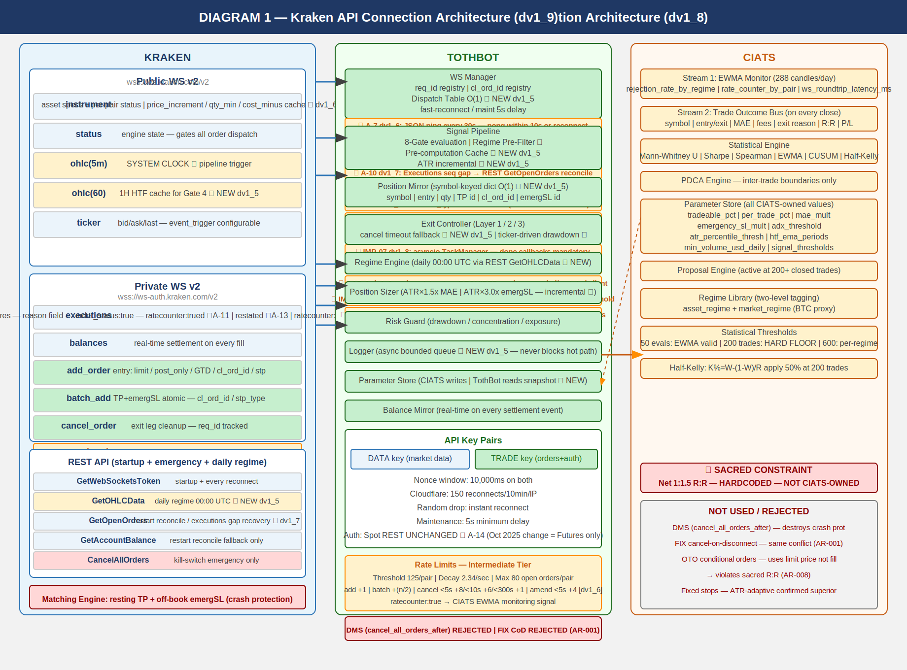

2.1 Key Connection Points
PUBLIC WS v2 (wss://ws.kraken.com/v2):
instrument — asset specs + per-pair status cache ★ dv1_6
price_increment / qty_min / cost_min ★ GAP-C/D dv1_9
status — global engine state (online/post_only/cancel_only/maintenance)
ohlc(5m) — SYSTEM CLOCK (pipeline trigger, fires on trade events)
ohlc(60) — 1H HTF cache for Gate 4 ★ NEW dv1_5
ticker — price data, event_trigger:bbo (pairs with open positions) or
event_trigger:trades (pairs without). WS Manager manages per-pair.

PRIVATE WS v2 (wss://ws-auth.kraken.com/v2):
executions — fills/expirations/SL-TP triggers, ratecounter:true (A-1),
snap_orders:true, snap_trades:true, order_status:true MANDATORY (AR-026)
sequence gap detection ★ A-10 dv1_7
balances — real-time settlement, sequence gap detection ★ A-9 dv1_6

PRIVATE WS v2 OUTBOUND:
add_order — entry: limit/post_only/GTD/cl_ord_id/stp_type:cancel_newest/deadline:now+5s
amend_order — PRIMARY amendment method (edit_order DEPRECATED ★ dv1_6)
batch_add — SL+TP atomic on fill. cl_ord_id/stp_type:cancel_newest/deadline:now+5s
cancel_order — exit leg cleanup, req_id tracked (Layer 2 MAE — individual ACK)
batch_cancel — Full Halt multi-order cancel ★ dv1_6 (bypasses rate counter)

REST (startup + emergency only):
GetWebSocketsToken — startup/reconnect
GetOHLCData — daily regime + warm-up (interval=5, 60, 1440). Exclude response[-1]
GetOpenOrders — restart reconcile fallback / executions gap recovery ★ dv1_7
GetAccountBalance — restart reconcile fallback / balances gap recovery
CancelAllOrders — kill switch emergency only
Status API — startup proactive maintenance check (AR-038 dv1_12)
GET https://status.kraken.com/api/v2/scheduled-maintenances/upcoming.json

2.2 Four Kraken Engine States
online — All orders. Signal pipeline runs normally.
post_only — TothBot limit+post_only entries ARE valid. Trading continues.
cancel_only — No new entries. Exit Controller can cancel. Resting orders active.
maintenance — No orders, no cancels. Resting TP and emergSL active on engine.

2.3 API Rate Limits — Intermediate Tier
Rate counter threshold (per pair): 125 (use maxratecount from executions ACK — AR-030)
Rate counter decay (per second): 2.34
Add order fixed cost: +1
amend_order cost ★ PRIMARY: +1 fixed, +3(<5s), +2(<10s), +1(<15s)
edit_order (DEPRECATED): +1 fixed, +6(<5s), +5(<10s) — DO NOT USE
Batch add fixed cost: +(n/2)
cancel_order (< 5s old): +8
cancel_order (< 10s old): +6
cancel_order (< 300s old): +1
batch_cancel: Cumulative sum of individual order cancel costs
amend_order is 43% cheaper than edit_order for orders resting <5s (+4 vs +7).

3. TothBot Trading Pipeline

Diagram 2 — TothBot Trading Pipeline
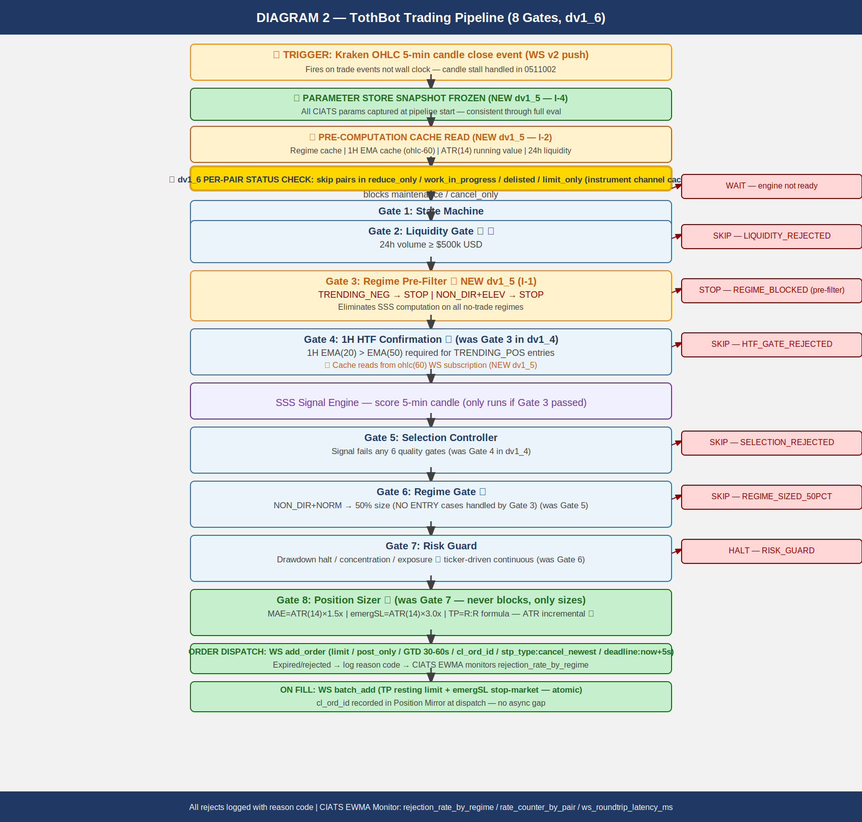
The pipeline fires on every 5-minute OHLC candle close event. Synchronous and event-driven. 8 gates. Gate 3 (Regime Pre-Filter) new in dv1_5. Per-pair status check new in dv1_6.

3.1 Gate Summary
PRE-STEP: Parameter Store Snapshot Frozen (NEW dv1_5 — I-4)
CIATS params captured as read-only snapshot at pipeline start.
PRE-STEP: Pre-Computation Cache Read (NEW dv1_5 — I-2)
Hot path reads: regime cache | 1H EMA cache | ATR(14) | 24h liquidity | per-pair status.
Per-pair Instrument Status Check (★ dv1_6)
Skip: reduce_only, work_in_progress, delisted, limit_only, cancel_only, maintenance
Only online or post_only pairs proceed into pipeline.
Gate 1: State Machine — Kraken engine = maintenance or cancel_only: WAIT
Gate 2: Liquidity Gate — 24h volume < $500k USD: SKIP → LIQUIDITY_REJECTED
Gate 3: Regime Pre-Filter ★ (NEW dv1_5)
TRENDING_NEG (any vol) or NON_DIR+ELEVATED: STOP → REGIME_BLOCKED
Gate 4: 1H HTF Confirmation ★
1H EMA(20) <= EMA(50) for TRENDING_POS entries: SKIP → HTF_GATE_REJECTED
SSS Signal Engine — Scores 5-min candle.
Gate 5: Selection Controller — Signal fails any of 6 quality gates: SKIP
Gate 6: Regime Gate ★ — NON_DIR+NORMAL: 50% position size.
Gate 7: Risk Guard — Drawdown halt / concentration / exposure. Pass or HALT.
★ Ticker-driven continuous drawdown monitoring between candle closes (I-7 dv1_5)
Gate 8: Position Sizer ★ — MAE=ATR×1.5x, emergSL=ATR×3.0x, TP=R:R formula.

4. Exit Architecture — Ground Zero Redesign for Kraken

Diagram 3 — Exit Architecture: Ground Zero Redesign
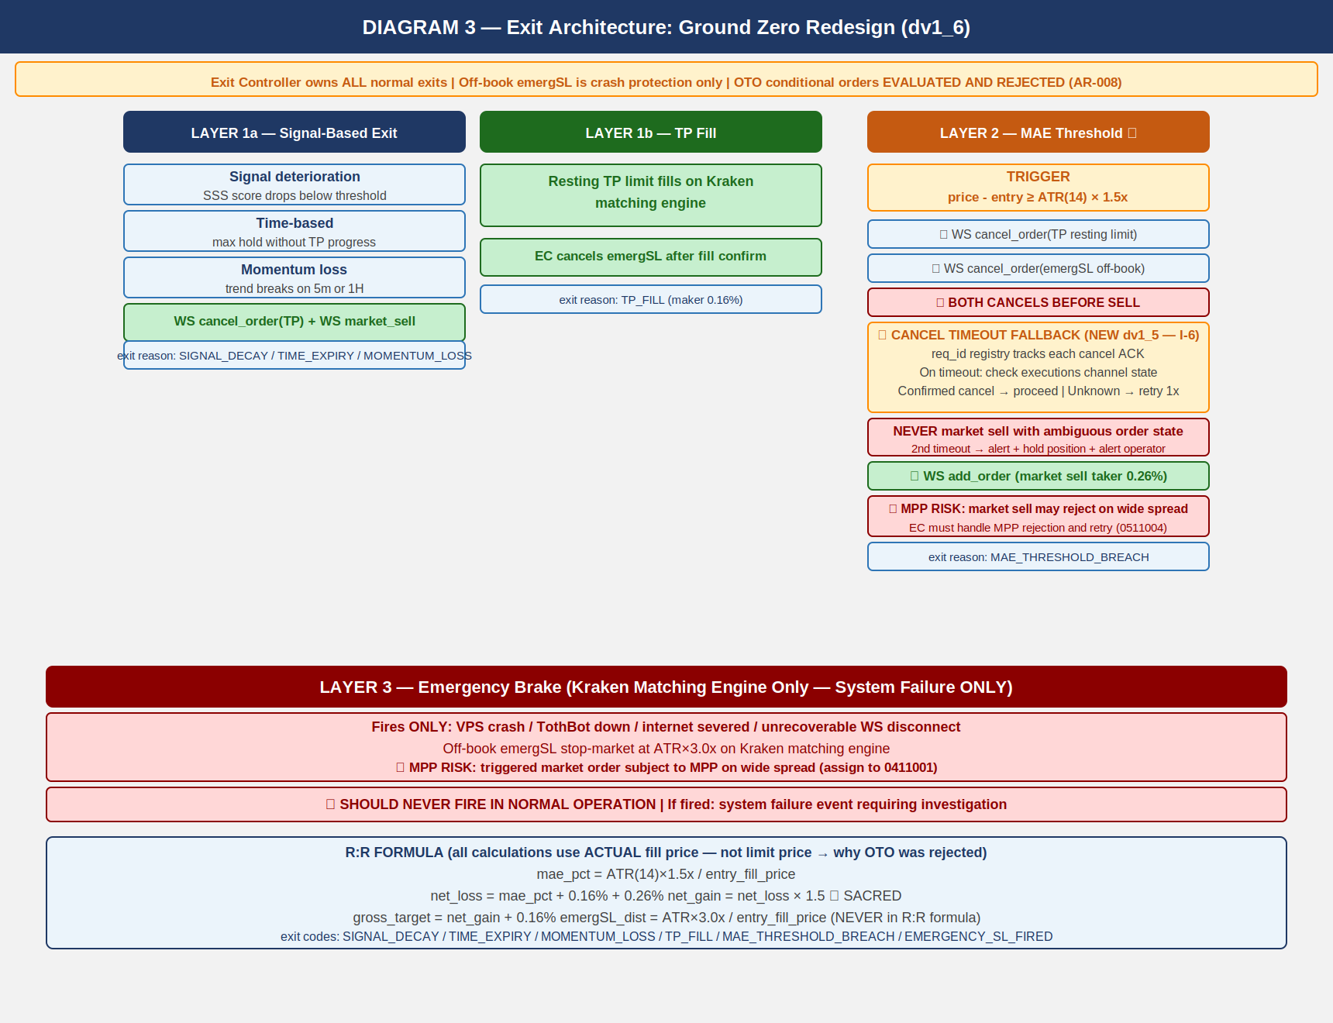

4.1 Three-Layer Summary
Layer 1a — Signal-Based Exit:
Signal decay / time expiry / momentum loss. WS cancel TP + market sell.
EC-L1A-001: 1H EMA(20) crosses below EMA(50) while long open → exit (★ dv1_14)
EC-L1A-002: Daily regime reclassification to NO-ENTRY while long open → exit (★ dv1_14)
EC-L1A-003: max_hold_candles timeout (TBD — pending OI-001 SSS) (★ dv1_14)
Layer 1b — TP Fill:
Resting TP limit on Kraken matching engine fills. EC cancels emergSL after fill.
★ TP partial fill: amend emergSL qty via amend_order (not cancel+resubmit) (AR-066 dv1_14)
Layer 2 ★ — MAE Threshold:
bid_price triggers when: entry_fill_price - bid_price >= ATR(14) × 1.5x
SEQUENCE: (1) cancel TP (2) cancel emergSL THEN (3) market sell
Cancel timeout fallback per I-6. MPP rejection handling per C-1.
Layer 3 ★ — Emergency Brake:
VPS/TothBot/internet failure ONLY. Off-book emergSL at ATR(14) × 3.0x.
triggers.reference = "last" MANDATORY. NEVER in normal operation.

4.2 R:R Formula
mae_pct = ATR(14) × 1.5x / entry_fill_price (uses ACTUAL fill price)
net_loss = mae_pct + 0.16% + 0.26% (entry maker + MAE taker exit)
net_gain = net_loss × 1.5 *** SACRED — hardcoded ***
gross_target = net_gain + 0.16% (TP maker exit)
emergSL_dist = ATR(14) × 3.0x / entry_fill_price (NEVER in R:R formula)

5. Regime Taxonomy

Diagram 4 — Regime Taxonomy: 6-Regime Grid + Two-Level Tagging
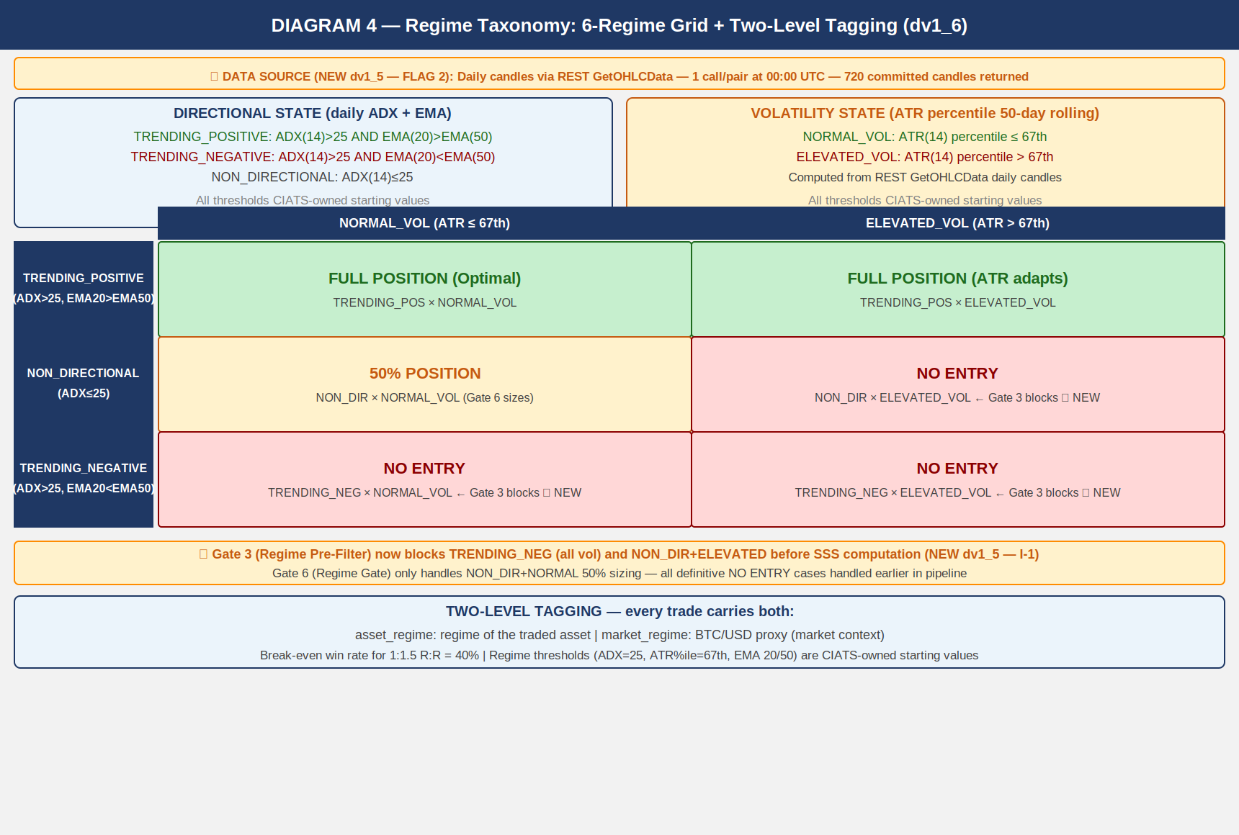

5.1 Computation
DATA SOURCE: Daily candles via REST GetOHLCData at 00:00 UTC. Returns 720 entries.
CRITICAL: response[-1] = always uncommitted candle. ALWAYS EXCLUDE (use response[:-1]).

Directional: ADX(14) + EMA(20) vs EMA(50) on DAILY candles
Volatility: ATR(14) percentile rank in 50-day rolling window

TRENDING_POSITIVE: ADX(14) > 25 AND EMA(20) > EMA(50)
TRENDING_NEGATIVE: ADX(14) > 25 AND EMA(20) < EMA(50)
NON_DIRECTIONAL: ADX(14) <= 25
NORMAL_VOL: ATR percentile <= 67th
ELEVATED_VOL: ATR percentile > 67th

asset_regime + market_regime (BTC/USD proxy) tagged on every trade.
Stagger: asyncio.sleep(1.1) between each pair call (1 call/sec rate limit).
ADX convergence: 128 candles required. 719 available = 5.6x excess.

6. CIATS Architecture and Data Flows

Diagram 5 — CIATS Architecture: Data Flows and Improvement Cycle
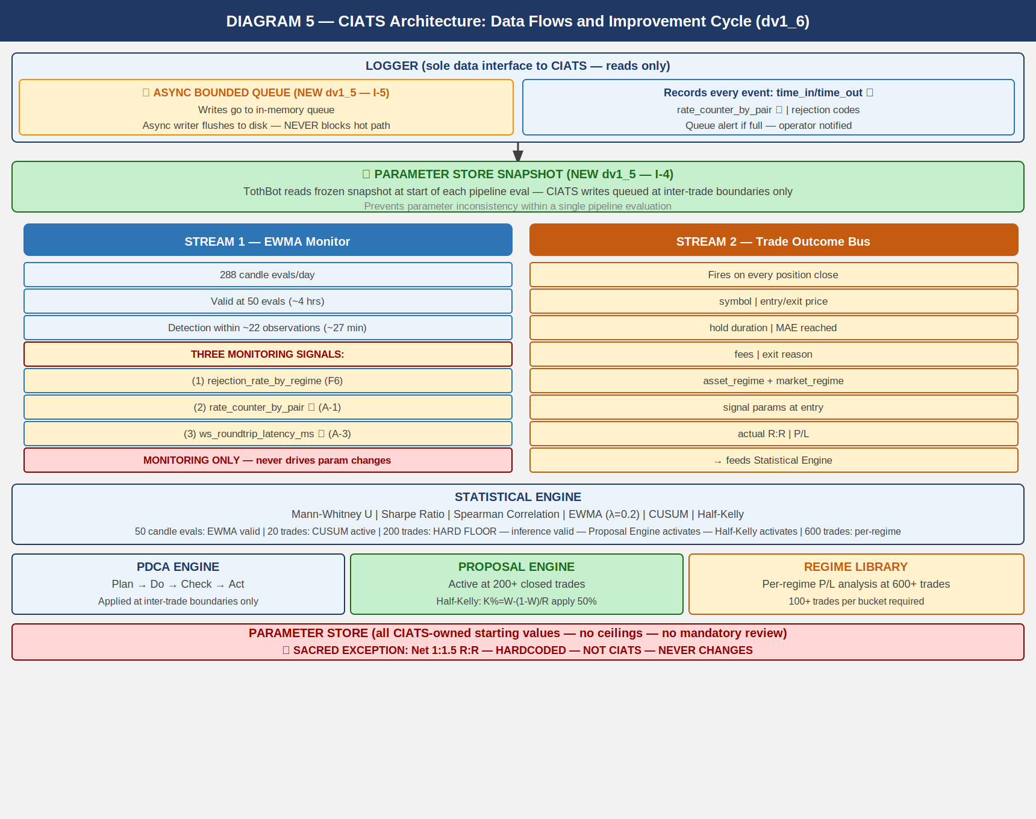

6.1 Two Data Streams
Stream 1: EWMA Monitor — 288 evals/day. Valid at 50 evals. lambda=0.2.
(1) rejection_rate_by_regime (F6)
(2) rate_counter_by_pair from executions channel (A-1)
(3) ws_roundtrip_latency_ms from WS response timestamps (A-3)
MONITORING SIGNALS ONLY — never drives parameter changes.

Stream 2: Trade Outcome Bus — fires on each position close.
symbol | entry/exit price | hold duration | MAE reached | fees
exit_reason | both regime tags | signal params | actual R:R | net P/L

LOGGER — queue.Queue(maxsize=10000) + QueueHandler + QueueListener thread (AR-063 dv1_14)
NEVER asyncio.Queue. QueueListener runs in separate thread. Non-blocking hot path.

PARAMETER STORE — Snapshot Pattern (NEW dv1_5)
TothBot reads frozen snapshot at pipeline eval start.
CIATS writes only at inter-trade boundaries.

6.2 Statistical Thresholds
50 candle evals: EWMA valid. Monitoring only.
200 trades HARD FLOOR: Inference valid. Proposal Engine. Half-Kelly activates.
600 trades: Per-regime analysis. 100+ per bucket.
Mann-Whitney alpha: 0.01 (one-sided)
Spearman threshold: |rho| > 0.3 AND p < 0.05
CUSUM parameters: k=0.5*sigma, h=4*sigma
PDCA minimum interval: 50 trades between any two parameter changes
Kelly inputs (★ AR-065 dv1_14): W and R from REALIZED NET P/L (Trade Outcome Bus)
NOT gross price change. NOT theoretical targets.

7. Complete System: One CIATS-Owned Organism

Diagram 6 — Complete System: One CIATS-Owned Organism
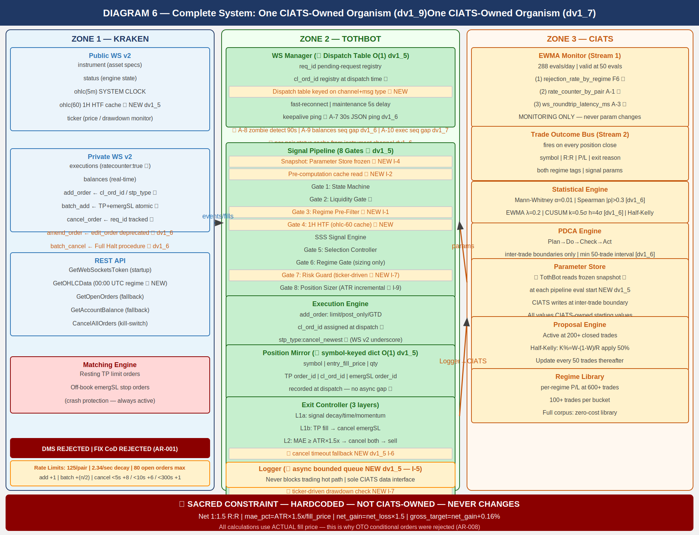
CIATS OWNS EVERYTHING EXCEPT 1:1.5 R:R: All parameters, thresholds, sizing decisions, halt thresholds, multipliers, and trading rules are CIATS-owned starting values.

8. Locked Architectural Decisions

AR-001: No Dead Man Switch — crash protection is resting TP + emergSL on matching engine.
DMS and FIX cancel-on-disconnect both REJECTED (destroy crash protection).
AR-002: Position Mirror — symbol-keyed dict, O(1) lookup. (NEW dv1_5 — I-3)
AR-003: Restart reconciliation — PREFERRED: snap_orders:true. FALLBACK: REST.
AR-004: Two API key pairs — DATA + TRADE. Nonce window 10,000ms.
AR-005: WS v2 only. All future Kraken enhancements in v2 only.
AR-006: Entry order — limit/post_only/GTD/cl_ord_id/stp_type:cancel_newest/deadline:now+5s.
★ WS v2 uses underscore in stp_type values (cancel_newest). REST uses hyphen (cancel-newest).
Never confuse the two. Different protocols, different formats.
AR-007: TP placement — resting limit via batch_add on fill. Actual fill price for R:R.
batch_add includes deadline:now+5s and stp_type:cancel_newest on both legs.
AR-008: Emergency SL — stop-market via batch_add atomic with TP. ATR(14) x 3.0x.
OTO evaluated and REJECTED: uses limit price, violates R:R, Position Mirror race.
AR-009: Short deferred.
AR-010: 24/7/365. CIATS adds stand-down via PDCA if data supports.
AR-011: Net 1:1.5 R:R — SACRED — HARDCODED — NOT CIATS-OWNED.
AR-012: Fee baseline — Maker 0.16% / Taker 0.26%.
AR-013: Kraken Pro Intermediate tier confirmed.
AR-014: Logger async bounded queue (10,000 entries). Never blocks hot path. (dv1_5 I-5)
AR-015: WS dispatch table O(1) routing on channel+message type. (dv1_5 I-8)
AR-016: ATR(14) incremental running calculation. O(1) per update. (dv1_5 I-9)
AR-017: Daily regime via REST GetOHLCData at 00:00 UTC. CRITICAL: exclude response[-1].
(dv1_5 FLAG 2)
AR-018 (dv1_6) ★: amend_order PRIMARY. edit_order DEPRECATED.
AR-019 (dv1_6) ★: batch_cancel for Full Halt multi-order cancellation.
AR-020 (dv1_6) ★: Per-pair instrument status cache from instrument channel.
AR-021 (dv1_7) ★: Executions channel sequence gap detection → REST GetOpenOrders
reconciliation. Missed executions = Position Mirror desync = loss risk.
AR-022 (dv1_8) ★: cancel_reason field deprecated — use reason field in all executions
channel parsing. cancel_reason returns None silently on current messages.
AR-023 (dv1_8) ★: Complete exec_type dispatch table required. All 10 exec_type values
handled explicitly. Unknown values logged, never silently dropped.
AR-024 (dv1_8) ★: restated exec_type = engine maintenance amend, NOT fill/cancel.
Must not trigger Position Mirror update. Elevated alert if resting order.
AR-025 (dv1_8) ★: All REST calls via aiohttp (IMP-06). asyncio TaskManager pattern
mandatory for 24/7 operation (IMP-07). systemd WatchdogSec=120 with
30-second asyncio ping loop (IMP-08). See 1011013 VPS_Deployment_Spec.
AR-026 (dv1_9) ★: order_status:true MANDATORY in executions subscription. Without it
amended and restated exec_types are silently dropped — A-12/A-13 blind.
AR-027 (dv1_9) ★: interval_begin replaces deprecated timestamp in OHLC WS v2 channel.
AR-028 (dv1_9) ★: price_increment replaces deprecated tick_size in instrument channel.
qty_min and cost_min validated in Gate 8 before every add_order.
AR-029 (dv1_9) ★: WS connect max_size=10MB + open_timeout=10 on all connections.
AR-030 (dv1_9) ★: maxratecount from executions subscription ACK is the operative rate
counter ceiling. Use it, not the hardcoded 125.
AR-031 (dv1_9) ★: Subscription ACK warnings[] parsed and logged on every subscribe call.
QueryOrdersInfo REST endpoint for targeted single-order reconciliation.
AR-032 (dv1_10) ★: stp_type FORMAT CORRECTION — WS v2 uses underscores: cancel_newest,
cancel_oldest, cancel_both. REST uses hyphens: cancel-newest. Never
confuse the two protocols. All WS v2 add_order and batch_add MUST use
cancel_newest (underscore). Assign: 0411001, 1011002.
AR-033 (dv1_10) ★: deadline parameter on all WS v2 add_order and batch_add.
Standard: deadline = UTC now + 5 seconds (ISO 8601 string).
Range 500ms–60s. Engine rejects orders arriving after this time.
Provides latency protection on entry and TP/emergSL placement.
Assign: 0411001 WS-DL-001–004, 1011002 WM-DL-001–004.
AR-034 (dv1_10) ★: Ticker event_trigger per position state:
event_trigger:bbo — pairs WITH open positions (faster adverse price
detection; for longs, bid = realizable exit price).
event_trigger:trades — pairs WITHOUT open positions (less update volume).
WS Manager switches trigger mode based on Position Mirror state.
Assign: 0411001 WS-TKR-001–004, 1011002 WM-TKR-001–004.
AR-035 (dv1_10) ★: aiohttp ClientSession MUST configure explicit timeout + connector:
ClientTimeout(total=10, connect=5, sock_read=8)
TCPConnector(limit=10, limit_per_host=5, force_close=False)
Without timeout, REST calls hang indefinitely on degraded networks.
force_close=False enables connection reuse for reduced per-call overhead.
Assign: 1011002 WM-REST-006–011, 1011001 BP-HTTP-001–004.
AR-036 (dv1_10) ★: Regime Engine REST calls MUST be staggered at 1.1s intervals.
REST public OHLC rate-limit: 1 call/second per IP+pair.
50 pairs × 1.1s = 55s total. Completes before first 5m candle.
asyncio.sleep(1.1) between each GetOHLCData call.
Assign: 1011012 RE-RL-001–004.
AR-037 (dv1_10) ★: Both DATA and TRADE API keys MUST be IP-whitelisted to VPS IP.
Current VPS: 87.99.141.44. Update whitelist on any VPS migration.
IP whitelisting is configured separately in Kraken API key settings.
Assign: 1011013 VD-KEY-006–009.
AR-038 (dv1_12) ★: Kraken Status API used at startup for proactive maintenance detection.
Public REST API at https://status.kraken.com/api/v2/. Query
/scheduled-maintenances/upcoming.json on startup. If scheduled
maintenance detected within 2 hours: log KRAKEN_MAINTENANCE_SCHEDULED,
alert operator. Does NOT block startup — informational only.
Assign: 0411001 WS-STAT-001 through -004, 1011013 VD-STAT-001.
AR-039 (dv1_12) ★: Per-pair instrument channel status check expanded. Complete set of
NO-ENTRY states: reduce_only, work_in_progress, delisted, limit_only,
cancel_only, maintenance. cancel_only and maintenance were previously
missing. Both block all new order placement at the pair level.
Assign: 0411001 WS-INST-008 through -011, 1011002 WM-PS-001 through -005.
AR-040 (dv1_12) ★: Exit Controller pair status adaptation for open positions.
limit_only → IOC limit at best_bid (NOT market sell).
cancel_only → HOLD + CRITICAL alert. No new orders possible.
maintenance (pair level) → HOLD + CRITICAL alert.
Existing resting TP + emergSL are the only protection during HOLD.
Validates AR-001: resting emergSL crash protection is the correct
architecture for pair-level disruption scenarios.
Assign: 0411001 WS-EXIT-001 through -006, 1011002 WM-PS-003/004.
AR-041 (dv1_12) ★: cancel_order/batch_cancel behavioral distinction — NOT interchangeable.
cancel_order: returns stream of individual responses per order (req_id
trackable). Use for Layer 2 MAE exit cancel sequence (cancel timeout
fallback I-6 requires per-order ACK tracking).
batch_cancel: returns single count response + bypasses rate counter
maximum. Use for Full Halt (count sufficient; rate bypass ensures
execution even when rate limited).
Assign: 0411001 WS-CAN-001 through -007, 1011002 WM-CAN-001 through -004.
AR-042 (dv1_12) ★: Zombie detection heartbeat exclusion. Heartbeat messages fire ONLY when
no real market data is flowing — they are an indicator of zombie state,
NOT connection health. last_real_data_time MUST be reset only on real
channel events: ohlc, ticker, instrument, executions, balances, status.
Heartbeat, pong, and ACK messages MUST NOT reset the timer.
Assign: 1011002 WM-ZOM-004 through -007.
AR-043 (dv1_12) ★: max_concurrent position limit enforced by asyncio.BoundedSemaphore.
BoundedSemaphore raises ValueError on over-release (bug detection).
Gate 7 checks semaphore.locked() (non-blocking). Execution Engine
acquires semaphore before dispatch. Position close triggers release.
On CIATS max_concurrent update: recreate semaphore, re-acquire for
all currently open positions.
Assign: 1011011 RE-SEM-001 through -006.
AR-044 (dv1_13) ★: Startup warm-up — ATR(14) and EMA via REST GetOHLCData required
before any pipeline execution. WS ohlc(5m) and ohlc(60) snapshots
return only 1 candle — insufficient to seed ATR(14) or EMA(20/50).
For each monitored pair at startup:
(a) GetOHLCData(interval=5) — seed ATR(14). Use response[:-1].
ATR seed = SMA of first 14 True Ranges. Incremental thereafter.
(b) GetOHLCData(interval=60) — seed EMA(20) and EMA(50) for HTF
cache. Use response[:-1]. EMA alpha=2/(n+1).
(c) GetOHLCData(interval=1440) — Regime Engine. Use response[:-1].
STAGGER: 1.1s between calls for the SAME pair (AR-036 applies).
PARALLELISM: asyncio.gather() across DIFFERENT pairs.
While ATR or EMA not seeded: pair remains in WARM_UP state.
WARM_UP pairs are skipped at the pipeline pre-check (no entries).
Pair transitions WARM_UP -> READY when ATR, EMA, and regime all
seeded. System begins trading READY pairs immediately — does not
wait for all pairs.
Assign: 1011002 WM-STARTUP-001 through -008,
1011014 SS-WARMUP-001 through -010.
AR-045 (dv1_13) ★: OHLC candle-close detection mechanism. WS OHLC fires on every
trade event within the candle period, not only on candle close.
WS Manager MUST track per symbol:
last_interval_begin: dict[str, str]
last_complete_candle: dict[str, OHLCCandle]
On each ohlc(5m) message for symbol S:
if msg.interval_begin == last_interval_begin[S]:
Update in-progress candle. DO NOT fire pipeline.
else:
Candle for last_interval_begin[S] is NOW CLOSED.
Fire pipeline with last_complete_candle[S].
last_complete_candle[S] = current message data.
last_interval_begin[S] = msg.interval_begin.
Initialize last_interval_begin[S] from startup GetOHLCData(5)
response[-2].interval_begin (last committed candle).
Same logic for ohlc(60) with separate last_interval_begin_60.
Assign: 1011002 WM-OHLC-001 through -006.
AR-046 (dv1_13) ★: emergSL triggers.reference MUST be explicit in all batch_add
calls. Never rely on API defaults for crash-protection parameters.
ALL emergSL stop-loss orders MUST include:
"triggers": {
"reference": "last",
"price": <sl_trigger_price>,
"price_type": "static"
}
reference="last" uses Kraken's internal last-traded price — always
available regardless of external index feed status. reference="index"
relies on external data providers that may be unavailable during
exactly the market crashes when emergSL needs to fire.
Assign: 0411001 WS-SL-001 through -003,
1011002 WM-BATCHADD-003 through -004.
AR-047 (dv1_13) ★: Price and quantity rounding before ALL order dispatch. ALL rounding
MUST use Decimal.quantize() — NEVER math.floor/ceil. Float binary
representation causes precision errors (e.g. math.floor(0.3/0.1)*0.1
= 0.2 not 0.3). For exchange orders: any rounding error = rejected
order = failed trade = loss. Four mandatory rounding operations:
(1) order_qty: Decimal.quantize(qty_increment, ROUND_DOWN).
If result < qty_min OR result*price < cost_min: SKIP, log.
(2) entry limit_price: Decimal.quantize(price_increment, ROUND_DOWN).
Conservative: lower limit = more likely post_only fill.
(3) TP limit_price: Decimal.quantize(price_increment, ROUND_UP).
Conservative: higher TP = preserves net R:R at minimum.
(4) emergSL trigger: Decimal.quantize(price_increment, ROUND_DOWN).
Conservative: wider stop = more protective.
ALL Kraken API values (prices, qtys) received via WS or REST MUST be
converted to Decimal(str(value)) immediately on receipt.
NEVER Decimal(float_value) — inherits float precision error.
NEVER dispatch batch_add without pre-validated, pre-rounded prices.
A batch_add validation failure at Kraken kills the entire batch,
leaving an open position with NO TP and NO emergSL protection.
Assign: 1011001 BP-DEC-001 through -008,
1011002 WM-ROUND-001 through -012.
AR-048 (dv1_13) ★: Exit Controller MAE detection and drawdown calculation MUST use
bid price (not last price) for long positions.
bid = best price at which the position can be immediately sold
(realizable exit value). last = most recent trade, can be stale.
event_trigger:bbo was chosen specifically because bid updates fire
immediately on any adversarial price move.
MAE formula: current_mae = entry_fill_price - bid_price
Layer 2 exit triggers when: current_mae >= ATR(14) * mae_mult
Drawdown calculation:
current_portfolio_USD = spot_usd_balance
+ sum(bid_price[sym] * position_qty[sym]
for sym in position_mirror)
Assign: 0411001 WS-TKR-005 through -007,
1011002 WM-EC-001 through -003.
AR-049 (dv1_13) ★: Formal startup sequence required. TothBot MUST complete the
10-step startup sequence before any pipeline evaluation. No pipeline
evaluations permitted until at least one pair reaches READY state.
Complete specification in 1011014 Startup_Sequence_Coding_Spec.
Sequence: (1) Kraken Status API check, (2) GetWebSocketsToken,
(3) Connect public WS + subscribe, (4) Process instrument snapshot,
(5) Connect private WS + subscribe executions/balances,
(6) snap_orders reconciliation -> Position Mirror,
(7) Restore ticker subscriptions per position state,
(8) REST warm-up GetOHLCData (AR-044: interval=5, 60, 1440),
(9) First READY pair -> enter OPERATIONAL, (10) Continuous operation.
Assign: 1011002 WM-STARTUP-001 through -012, 1011014 (full spec).
AR-050 (dv1_13) ★: Balances channel MUST use spot/main wallet balance only.
The balances snapshot top-level "balance" field is the SUM across
ALL wallet types (spot, earn, futures, flex, etc.). Earn/staking
balances are NOT available for trading. Using top-level balance
overstates tradeable capital and causes incorrect position sizing
and drawdown calculations.
Correct extraction: wallets[type="spot"][id="main"].balance
On balances snapshot: iterate wallets array, filter type=="spot"
AND id=="main". Store as Decimal(str(wallet.balance)).
On balances update: filter wallet_type=="spot" AND wallet_id=="main".
Two update events per completed trade: base currency debit + quote
currency credit, both sharing the same ref_id.
For portfolio tracking: process only USD event (asset=="USD").
Assign: 0411001 WS-BAL-001 through -005,
1011002 WM-BAL-001 through -006.
AR-051 (dv1_13) ★: Portfolio value definition for position SIZING:
portfolio_USD = spot_usd_balance (spot/main wallet, USD only)
This is REALIZED CAPITAL ONLY. Does NOT include mark-to-market
value of open positions. Using MTM for sizing creates a feedback
loop: rising positions inflate sizing of new positions, increasing
total risk beyond intent. Cash-in-hand is the only correct basis.
tradeable_USD = portfolio_USD * tradeable_pct
per_trade_USD = tradeable_USD * per_trade_pct
raw_qty = per_trade_USD / entry_limit_price
At 200+ closed trades, CIATS activates Half-Kelly:
K_full = W - ((1-W)/R)
K_half = K_full * 0.5
per_trade_USD = min(K_half*tradeable_USD,
tradeable_USD/max_concurrent)
NOTE: Drawdown calculation uses a DIFFERENT formula (see AR-052).
Sizing and drawdown are two separate computations.
Assign: 1011002 WM-PS-005 through -009,
1011011 RE-SZ-001 through -005.
AR-052 (dv1_13) ★: Portfolio drawdown formula and circuit breakers:
BASELINE: portfolio_baseline_USD = spot_usd_balance captured ONCE
at startup (after Step 6 snap_orders processing). NEVER updated
during operation. NEVER reset on mid-session reconnect.
Resets only on full TothBot process restart.
CURRENT PORTFOLIO (for drawdown — includes MTM):
current_portfolio_USD = spot_usd_balance
+ sum(bid_price[sym] * position_qty[sym]
for sym in position_mirror)
Uses bid price (AR-048) — realizable exit value, conservative.
DRAWDOWN:
drawdown_pct = max(0,
(portfolio_baseline_USD - current_portfolio_USD)
/ portfolio_baseline_USD)
max(..., 0): gains are not counted as negative drawdown.
EVALUATION: on every bbo ticker event for any open-position pair
AND at every Gate 7 evaluation.
THRESHOLDS:
session_pause_drawdown (5%): no new entries. Alert. Existing
positions monitored normally. Resumes when drawdown recovers.
full_halt_drawdown (10%): HALT. No new entries. Alert Bill.
Does NOT auto-close positions. Bill decides.
Assign: 1011002 WM-DD-001 through -008,
1011011 RE-DD-001 through -006.
AR-053 (dv1_13) ★: Pending Order Registry — USD commitment tracking to prevent
capital overcommitment when multiple pairs fire pipeline
simultaneously. WS balances channel does NOT expose hold_trade
(pending order USD holds). TothBot must self-track.
REGISTRY: pending_orders: dict[str, Decimal]
maps cl_ord_id -> estimated_USD_cost
POPULATE on entry dispatch:
estimated_cost = order_qty * entry_limit_price * (1 + maker_fee)
pending_orders[entry_cl_ord_id] = estimated_cost
CLEAR on: exec_type=filled, expired, or canceled.
HOLD on: exec_type=trade (partial fill — order still open).
GATE 7 USD CHECK:
available_USD = spot_usd_balance - sum(pending_orders.values())
if available_USD < per_trade_USD: SKIP_INSUFFICIENT_USD
RECONCILIATION at startup (Step 6) and on mid-session reconnect:
snap_orders "new"/"pending_new" -> populate registry.
orders NOT in snap_orders -> clear from registry.
Assign: 1011002 WM-POR-001 through -007,
1011011 RE-SZ-005.
AR-054 (dv1_13) ★: Entry order partial fill + expiry/cancel creates unprotected open
position. A GTD post_only entry order can receive partial fills
before the GTD window expires or the order is canceled. When
exec_type=="expired" OR exec_type=="canceled" AND cum_qty > 0:
a REAL position exists at cum_qty units at avg_price fill price,
with NO TP and NO emergSL protection. Must be handled immediately.
CASE A (exec_type=="expired" AND cum_qty > 0):
CASE B (exec_type=="canceled" AND cum_qty > 0):
1. Clear Pending Order Registry for this cl_ord_id.
2. Extract qty=Decimal(str(cum_qty)), entry=Decimal(str(avg_price)).
3. Validate qty >= qty_min AND qty*entry >= cost_min.
If not: dispatch market sell immediately. Log and fire CIATS.
4. Recalculate TP and emergSL from actual entry price using
current ATR(14) and mae_mult / emergency_sl_mult.
Verify net_gain = net_loss * 1.5 (sacred R:R).
5. Dispatch batch_add: TP limit + emergSL stop, using cum_qty.
6. Enter Position Mirror with cum_qty and avg_price.
7. Log ENTRY_PARTIAL_FILL_PROTECTED.
CASE C (exec_type=="expired" OR "canceled" AND cum_qty == 0):
No fill. Clear registry. Log. No position opened.
CASE D (exec_type=="filled"): Unchanged. No partial fill concern.
Assign: 1011002 WM-DISP-020 through -028.
AR-055 (dv1_13) ★: Dead Man's Switch (cancel_all_orders_after) is EXPLICITLY
PROHIBITED in TothBot V2. No call to this endpoint under any
circumstance. RATIONALE: DMS cancels ALL account orders when timer
expires — including emergSL orders protecting open positions (Layer 3
crash protection). DMS would destroy the only Kraken-side protection
for open positions during the exact scenario (VPS crash, network
severance) that emergSL is designed to protect against.
PROTECTION IS FULLY PROVIDED WITHOUT DMS:
Entry orders: GTD self-expiry in 30-60 seconds.
Open positions: emergSL resting on Kraken matching engine.
Process crash: systemd WatchdogSec=120 restarts TothBot.
Network breakdown: emergSL survives on Kraken regardless.
HARD RULE: Code review MUST reject any PR containing a call to
cancel_all_orders_after (WS v2 or REST endpoint).
Assign: HR-DMS-001 in 0411001 and 1011002.
AR-056 (dv1_13) ★: Mid-session WS reconnect sequence is DISTINCT from startup and
MUST be implemented separately. 11-step sequence. Key distinctions:
portfolio_baseline_USD: NEVER reset on reconnect.
drawdown_pct: PRESERVED across reconnect.
system_state (halt/pause): PRESERVED across reconnect.
ATR/EMA caches: PRESERVED unless gap > 15 minutes (stale threshold).
Position Mirror: reconciled via snap_orders comparison.
Positions closed during gap (TP/emergSL fired while disconnected):
detected by comparing pre-disconnect Position Mirror vs snap_orders.
CIATS Trade Outcome Bus fired for each gap-closed position.
Pending Order Registry: reconciled against snap_orders.
Pipeline evaluations: PROHIBITED during reconnect. Candle events
queued during reconnect are DISCARDED after completion.
Fatal reconnect: 10 attempts over 120 seconds -> log CRITICAL ->
systemd restart -> full startup sequence.
Complete specification in 1011014 Section 2.
Assign: 1011002 WM-RECONNECT-001 through -015,
1011014 SS-RECON-001 through -016.
AR-057 (dv1_14) ★: amended exec_type MUST be in dispatch table. The complete Kraken
executions channel exec_type list is 10 values: pending_new, new,
trade, filled, iceberg_refill, canceled, expired, amended, restated,
status. amended was missing from prior dispatch table (AR-023).
amended = user-initiated order amend (e.g. limit price change).
TothBot V1 never sends amend_order for its own orders. Any amended
exec_type event is unexpected and must be treated as a system
integrity alert: log UNEXPECTED_ORDER_AMENDED (CRITICAL level),
alert operator HIGH, cross-reference Position Mirror to determine if
TP or emergSL was amended (sacred R:R violation risk).
Do NOT auto-correct — operator must review and decide.
Assign: 0411001 WS-AMEND-001 through -003,
1011002 WM-DISP-024 through -026.
AR-058 (dv1_14) ★: websockets library max_queue=None REQUIRED on all connections.
Default max_queue=16 is insufficient for burst market data events
(startup instrument snapshot for 200+ pairs, rapid bbo ticker events
on multiple open positions, post-reconnect snapshots). Messages can
be silently dropped or backed up when queue is exceeded.
Set max_queue=None (unlimited) on all four websockets connections
(public WS, private WS, and their reconnect variants). Memory impact
is negligible. A dropped executions message = Position Mirror desync
= loss risk. Non-negotiable for 24/7 operation.
Assign: 1011002 WM-CONN-001 through -003.
AR-059 (dv1_14) ★: Disable websockets library ping, use application JSON ping only.
Set ping_interval=None on all websockets.asyncio.client.connect()
calls to disable the library's built-in TCP-level PING frames.
TothBot's sole keepalive mechanism is the application-level JSON
ping: {"method":"ping"} every 30 seconds (A-7), with pong expected
within 10 seconds. Running two concurrent ping mechanisms creates
duplicate activity and confusion. The JSON ping is fully visible to
TothBot application code; the library PING is transparent and
invisible. Single authoritative keepalive mechanism with full
visibility is the correct architecture.
Assign: 1011002 WM-CONN-004 through -006.
AR-060 (dv1_14) ★: All websockets connections MUST use the new stable asyncio API.
REQUIRED import: from websockets.asyncio.client import connect
DEPRECATED (DO NOT USE): import websockets; websockets.connect()
The legacy API is deprecated in websockets v14+ and will be removed
in a future release. Using it is a ticking time bomb for a 24/7
trading system — a library version update would silently break all
WS connections. Applies to: startup (1011014 SS-STARTUP-006,
SS-STARTUP-013), reconnect (1011014 SS-RECON-006), all WS connections.
Assign: 1011002 WM-CONN-007, 1011014 SS-PRE-006.
AR-061 (dv1_14) ★: Capture last_qty and last_price fields from executions trade events.
Kraken added last_qty (quantity of this specific fill) and last_price
(price of this specific fill) to exec_type=trade events. These are
fill-level fields, distinct from cumulative cum_qty and avg_price.
Position Mirror and sizing continue to use cum_qty and avg_price.
last_qty and last_price are captured for fill-level logging and CIATS
execution quality analytics (entry slippage monitoring).
All values: Decimal(str()) immediately on receipt per AR-047.
Assign: 0411001 WS-EXE-020 through -022,
1011002 WM-EXE-014 through -016.
AR-062 (dv1_14) ★: Exit Controller Layer 1a — three triggers now specified.
Three Layer 1a exit triggers are derivable before SSS (OI-001):
EC-L1A-001 (HTF Regime Reversal): 1H EMA(20) crosses below EMA(50)
while long open. Gate 4 symmetry. Check on every ohlc(60) close.
Exit sequence: cancel TP → cancel emergSL → market sell.
EC-L1A-002 (Daily Regime Downgrade): At 00:00 UTC regime refresh,
pair reclassified TRENDING_POS → TRENDING_NEG or NON_DIR+ELEVATED.
Gate 3 symmetry. Check immediately after regime computation.
Exit sequence: cancel TP → cancel emergSL → market sell.
EC-L1A-003 (Max Hold Time): max_hold_candles parameter. TBD value
pending OI-001 SSS specification. CIATS-owned starting value.
Both EC-L1A-001 and EC-L1A-002 use cancel timeout fallback (I-6).
Assign: 1011005 EC-L1A-001 through -012.
AR-063 (dv1_14) ★: Logger MUST use queue.Queue (stdlib), not asyncio.Queue.
CORRECT PATTERN:
log_queue = queue.Queue(maxsize=10000)
queue_handler = logging.handlers.QueueHandler(log_queue)
log_listener = logging.handlers.QueueListener(log_queue, file_handler)
log_listener.start() # Runs in its own thread
NOT asyncio.Queue: QueueListener runs in a separate non-asyncio
thread and is not compatible with asyncio.Queue. An asyncio coroutine
writer would compete with the event loop for scheduling.
On queue.Full: log to stderr, alert HIGH, skip record — NEVER block.
Stop listener on shutdown: log_listener.stop() drains and joins.
Assign: 1011007 LG-QUEUE-001 through -008.
AR-064 (dv1_14) ★: Log connection_id from Kraken status channel on every WS connection.
Status channel provides connection_id (uint64) per WS session — a
unique Kraken-side identifier. Log on every new connection. Include
in all reconnect, disconnect, and gap log entries. Useful for Kraken
support requests and debugging. Zero additional cost — already in
status channel message data.
Assign: 0411001 WS-STAT-005 through -006,
1011002 WM-STATUS-001.
AR-065 (dv1_14) ★: CIATS Kelly formula inputs MUST use net P/L from Trade Outcome Bus.
Kelly K_full = W - ((1-W)/R).
W = count(trades where net_gain_usd > 0) / total_trades.
R = mean(net_gain_usd for wins) / mean(|net_loss_usd| for losses).
Both W and R computed from Trade Outcome Bus realized net P/L data
(all fees included — entry maker + exit taker). NOT gross price change.
NOT theoretical R:R targets. For TothBot with 0.42% round-trip fees,
gross vs net R:R diverges meaningfully. Inflated Kelly from gross
inputs = oversized positions = excess loss on losers.
Negative K_full: log CRITICAL, alert operator, do not update params.
Assign: 1011010 CIATS-KE-006 through -009.
AR-066 (dv1_14) ★: TP order partial fill requires Position Mirror update + emergSL amendment.
When exec_type=trade arrives for a TP order (identified by order_id
matching TP order_id in Position Mirror):
remaining_qty = tp_order_qty - cum_qty
Update Position Mirror qty to remaining_qty
Amend emergSL to remaining_qty via amend_order (NOT cancel+resubmit)
Rate counter: amend_order (+2) saves 7 units vs cancel+resubmit (+9)
amend_order also preserves queue position in Kraken book
If remaining_qty < qty_min OR remaining_qty * bid < cost_min:
cancel emergSL, immediate market sell of remainder, clear Mirror
CIATS Trade Outcome Bus: fire ONCE on full position close (aggregate
all partial fill data). Not on each partial fill event.
On exec_type=filled (full TP fill): existing L1b logic unchanged.
Assign: 0411001 WS-TP-001 through -005,
1011002 WM-EC-004 through -008,
1011005 EC-TP-001 through -006.

9. Complete CIATS Parameter Registry

ALL PARAMETERS ARE CIATS-OWNED STARTING VALUES.
tradeable_pct: 50% of portfolio
per_trade_pct: 5% → Half-Kelly at 200 trades (update every 50 thereafter)
★ Applied_pct = min(raw_kelly_half, tradeable_pct/max_concurrent)
max_concurrent: 20 positions
mae_mult (ATR x): 1.5x ATR(14)
emergency_sl_mult: 3.0x ATR(14)
entry_timeout_sec: 30-60s GTD
full_halt_drawdown: 10% of portfolio
session_pause_drawdown: 5% of portfolio
signal_thresholds: SSS gates (derived)
adx_threshold: 25
atr_percentile_threshold: 67th
htf_ema_periods: 20/50 daily
min_volume_usd_daily: $500k USD
1:1.5 R:R net: HARDCODED — SACRED — NOT CIATS-OWNED

10. Six FP/DP Validated System Improvements

Finding 1: 1H HTF Confirmation Gate
Gap: No layer between daily regime and 5-min entry.
Evidence: 15-20% higher win rates with daily+hourly filter (5 sources 2024-2025).
Change: 1H EMA(20) > EMA(50) required for TRENDING_POSITIVE. Cache from ohlc(60).
Finding 2: ATR Dynamic Stop Distances
Gap: Fixed 2% stop ignores real-time market volatility.
Evidence: +15% performance, -22% max drawdown vs fixed stops.
Change: MAE ATR(14) × 1.5x. Emergency SL ATR(14) × 3.0x. Incremental (I-9).
Finding 3: Regime Gate
Gap: Long momentum system trading in absent-edge conditions.
Evidence: Accuracy 65%→45-50% in NON_DIRECTIONAL (Market Cipher). Break-even 40%.
Change: NON_DIR+ELEV and TRENDING_NEG: no entry. NON_DIR+NORM: 50% size.
Finding 4: Minimum Liquidity Gate
Gap: No minimum 24h volume on asset selection.
Evidence: $1M+/day minimum for clean execution.
Change: min_24h_volume_usd $500k starting.
Finding 5: CIATS Half-Kelly Pathway
Gap: Fixed 5% sizing had no defined data-driven transition.
Evidence: Half-Kelly: 75% optimal growth at 50% less drawdown.
Change: At 200 trades: K%=W-(1-W)/R, apply 50%. Update every 50 trades.
Inputs: W and R from REALIZED NET P/L from Trade Outcome Bus (AR-065 dv1_14).
Finding 6: post_only Rejection Monitoring
Gap: Rejection events logged but unused by CIATS EWMA.
Change: CIATS EWMA adds rejection_rate_by_regime stream.

11. Complete Trade Lifecycle — Narrative Reference

11.1 Normal Trade (Entry to TP or Exit Controller)
OHLC 5-min candle close fires on public WS v2
Parameter Store snapshot frozen — all CIATS params captured
Pre-computation cache read — regime, 1H EMA, ATR(14), 24h liquidity
★ Per-pair instrument status check — skip non-online/non-post_only pairs
Gate 1: State Machine — online or post_only: continue; else halt
Gate 2: Liquidity Gate — 24h volume >= $500k: continue; else skip
Gate 3: Regime Pre-Filter — TRENDING_NEG or NON_DIR+ELEV: STOP
Gate 4: 1H HTF Gate — 1H EMA(20) > EMA(50) for TRENDING_POS: continue
Signal Engine: SSS score computed on 5-min candle
Gate 5: Selection Controller — 6-gate quality evaluation
Gate 6: Regime Gate — TRENDING_POS: proceed; NON_DIR+NORM: 50% size
Gate 7: Risk Guard — drawdown/concentration/exposure checks
Gate 8: Position Sizer — MAE=ATR×1.5x, emergSL=ATR×3.0x, TP=R:R formula
Execution: WS add_order (limit/post_only/GTD/cl_ord_id/stp_type:cancel_newest/deadline:now+5s)
If expired/rejected: log reason code → CIATS EWMA monitors rejection rate.
If filled: WS batch_add → TP (resting limit) + emergSL (stop-market) atomic
Position Mirror records: symbol, entry_fill_price, qty, TP id, cl_ord_id, emergSL id
Exit Controller monitors via ticker (continuous drawdown — I-7)
On 1H EMA reversal → EC-L1A-001 exit (★ AR-062 dv1_14)
On daily regime downgrade → EC-L1A-002 exit (★ AR-062 dv1_14)
TP fills: EC cancels emergSL (L1b). On TP partial fill: amend emergSL qty (★ AR-066 dv1_14)
Or EC fires Layer 1a or Layer 2 MAE exit.
Logger records full exit. CIATS Trade Outcome Bus fires with complete trade record.

11.2 Layer 2 MAE Exit
Exit Controller detects: entry_fill_price - bid_price >= ATR(14) × 1.5x
WS cancel_order: cancel TP. WS cancel_order: cancel emergSL (SEQUENCE CRITICAL)
Cancel timeout fallback (I-6): track req_id. NEVER sell with ambiguous state.
WS add_order: market sell (taker 0.26%). Handle MPP rejection per C-1.
Logger: exit_reason = MAE_THRESHOLD_BREACH. CIATS Trade Outcome Bus fires.

11.3 Emergency SL (Layer 3 — System Failure Only)
VPS crashes / TothBot dies / internet severs / unrecoverable WS disconnect
Kraken matching engine fires off-book emergSL stop-market at ATR × 3.0x
triggers.reference = "last" MANDATORY (index feed unreliable in crashes)
On restart: reconciliation detects closed position → Logger: EMERGENCY_SL_FIRED
THIS IS A SYSTEM FAILURE EVENT. SHOULD NEVER FIRE IN NORMAL OPERATION.

12. Open Items — Require Specification Documents

OI-001: Signal generation (SSS) — FP/DP derivation required. Blocks 0811001, 0811002.
OI-002: Asset selection universe — Kraken USDT/USDC pairs.
OI-003: Exit Controller full specification — PARTIAL. EC-L1A-001 and EC-L1A-002 now
specified in 1011005 dv1_0. EC-L1A-003 (max_hold_candles) pending OI-001.
OI-004: Entry limit placement — evaluate bbo trigger, L2 book, L3 book.
OI-005: Selection Controller — 6-gate spec, must include per-pair status check.
OI-006: CIATS specification — all statistical thresholds and PDCA rules.
OI-007: AA=04 Exchange Interface formal document.
OI-008: All AA=10 coding specs. WD documents active: 1011001, 1011002, 1011005,
1011007, 1011010, 1011012, 1011013, 1011014.
Current versions: 0411001 dv1_9, 1011002 dv1_10, 1011005 dv1_0 (NEW),
1011007 dv1_0 (NEW), 1011010 dv1_3.

13. Revision History

dv1_0 03-23-2026 Initial document.
dv1_1 03-23-2026 Added all six system flow diagrams.
dv1_2 03-24-2026 Six changes: C-1 emergSL terminology, C-2 rate limits, C-3 OHLC stall,
A-1 ratecounter, A-2 req_id, A-3 latency logging.
dv1_3 03-24-2026 Rebuilt as correct .docx with all six diagrams embedded.
dv1_4 03-24-2026 Seven changes: C-1 MPP, A-1 AR-001 expansion, A-2 cl_ord_id,
A-3 snap_orders, A-4 stp_type, A-5 reconnect distinction, A-6 OTO rejected.
dv1_5 03-24-2026 Eleven changes: FLAG1 ohlc(60), FLAG2 REST GetOHLCData, I-1 Gate 3,
I-2 cache, I-3 Position Mirror O(1), I-4 Parameter Store snapshot,
I-5 Logger async queue, I-6 cancel timeout, I-7 ticker drawdown,
I-8 WS dispatch table, I-9 ATR incremental.
dv1_6 03-24-2026 Six changes from 10-search FP/DP validation + Operations/CIATS analysis:
(1) amend_order primary, edit_order deprecated, batch_cancel, L3 URL corrected.
(2) Rate table updated.
(3) A-7 WS ping, A-8 zombie detection, A-9 balances seq gap.
(4) Per-pair instrument status check, AR-018/019/020.
(5) GetOHLCData response[-1] exclusion — CRITICAL correctness requirement.
(6) Auth verification, CIATS statistical thresholds.
dv1_9 03-25-2026 Six new architectural requirements and five improvements from
second 10-search FP/DP organism validation session (TB00010):
A-15 (GAP-A CRITICAL) order_status:true mandatory in executions
subscription — without it amended/restated silently dropped, breaking
A-12/A-13. A-16 (GAP-B) OHLC interval_begin replaces deprecated
timestamp. A-17 (GAP-C/D) instrument price_increment replaces
tick_size; qty_min/cost_min mandatory Gate 8 validation. A-18 (GAP-E)
websockets max_size=10MB + open_timeout=10 mandatory. A-19 (IMP-11)
maxratecount from executions ACK is operative rate threshold. IMP-13
subscription warnings[] parsed/logged. IMP-14 amend_id logged. IMP-15
QueryOrdersInfo for targeted reconciliation. AR-026 through AR-031 added.
0411001 updated to dv1_2. 1011002 updated to dv1_2.
dv1_10 03-25-2026 Seven new findings from third 10-search FP/DP organism validation
(TB00011): A-20 stp_type FORMAT CORRECTION. A-21 deadline parameter.
A-22 aiohttp ClientTimeout + TCPConnector. A-23 Ticker event_trigger:bbo.
A-24 Regime Engine GetOHLCData stagger. AR-037 IP-whitelisting.
IMP-16 through IMP-19. AR-032 through AR-037. 0411001 dv1_3.
1011002 dv1_3. 1011012 dv1_1. 1011001 dv1_1.
dv1_12 03-25-2026 Ten text-only changes from fourth (TB00012), fifth (TB00013), and
sixth (TB00014) 10-search FP/DP validation sessions. No diagram changes.
AR-038: Kraken Status API startup maintenance check. Section 2 REST
table: Status API endpoint added. AR-039: per-pair status check
expanded — cancel_only and maintenance added as NO-ENTRY states.
AR-040: Exit Controller pair status adaptation — IOC limit on limit_only,
HOLD on cancel_only/maintenance. AR-041: cancel_order/batch_cancel
behavioral distinction — cancel_order for MAE exit (individual ACK),
batch_cancel for Full Halt (count + rate bypass). AR-042: zombie
detection heartbeat exclusion — heartbeats MUST NOT reset
last_real_data_time. AR-043: max_concurrent via asyncio.BoundedSemaphore.
Section 9 CIATS Parameter Registry: Half-Kelly normalization note.
Section 11.1: per-pair status check updated with full list.
0411001 updated to dv1_6. 1011002 updated to dv1_6.
1011010 updated to dv1_2. 1011011 dv1_0 new.
1011012 updated to dv1_2. 1001001 updated to dv1_3.
dv1_13 03-26-2026 Fourteen text-only changes from seventh (TB00015), eighth (TB00016),
and ninth (TB00017) 10-search FP/DP validation sessions. No diagram
changes. AR-044: startup warm-up via REST GetOHLCData — ATR(14) seed
(interval=5), EMA(20/50) seed (interval=60), regime (interval=1440).
WARM_UP/READY pair state machine. asyncio.gather across pairs, 1.1s
intra-pair stagger. AR-045: OHLC candle-close detection via
interval_begin change (not wall clock). last_interval_begin tracking
per symbol. AR-046: emergSL triggers.reference="last" explicit in all
batch_add calls — never rely on defaults for crash protection params.
AR-047: ALL rounding via Decimal.quantize() — NEVER math.floor/ceil.
Float arithmetic causes silent precision errors that corrupt order
prices. All Kraken API values: Decimal(str()) immediately on receipt.
AR-048: Exit Controller MAE uses bid price (not last) for long
positions. bid = realizable exit. drawdown formula uses bid.
AR-049: Formal 10-step startup sequence. No pipeline until READY.
Full spec in 1011014 Startup_Sequence_Coding_Spec.
AR-050: Balances channel — spot/main wallet only. Top-level balance
includes earn/staking (not tradeable). Filter wallets array.
AR-051: Portfolio for sizing = cash only (no MTM of open positions).
AR-052: Drawdown baseline set ONCE at startup. NEVER reset on
reconnect. Current portfolio = cash + bid*qty of open positions.
Session pause 5%, full halt 10%. Does not auto-close positions.
AR-053: Pending Order Registry — self-tracks USD committed to
outstanding entry orders. Gate 7 checks available_USD = balance
minus pending commitments. Prevents overcommitment on simultaneous
pipeline activations. AR-047 amendment: original AR-047 used
math.floor/ceil — amended to Decimal.quantize() (BP-DEC-001 through
BP-DEC-008 in 1011001). AR-054: Entry order partial fill + expiry or
cancel creates unprotected open position. cum_qty > 0 on expired or
canceled exec_type: recalculate TP/emergSL from avg_price, dispatch
batch_add, enter Position Mirror. If below qty_min/cost_min: market
sell immediately. AR-055: Dead Man's Switch (cancel_all_orders_after)
EXPLICITLY PROHIBITED. Cancels emergSL orders — destroys crash
protection. Hard rule: code review must reject any PR with this call.
AR-056: Mid-session WS reconnect sequence distinct from startup.
Never reset portfolio_baseline_USD or drawdown on reconnect. Reconcile
Position Mirror vs snap_orders. Detect positions closed during gap.
Fire CIATS Trade Outcome Bus for gap-closed positions. 15-minute
threshold for cache staleness. Full spec in 1011014 Section 2.
1011001 updated to dv1_4. 1011002 updated to dv1_9.
1011011 updated to dv1_1. 1011014 updated to dv1_1.
0411001 updated to dv1_8.
dv1_14 03-26-2026 Ten text-only changes from tenth 10-search FP/DP validation
session (TB00019 Pass 2). No diagram changes.
AR-057: amended exec_type added to dispatch table. TothBot V1
never amends own orders. Any amended event = CRITICAL alert.
AR-058: max_queue=None on all websockets connections. Default
max_queue=16 risks silent drops on burst market data events.
AR-059: ping_interval=None — disable library ping. Use only
application-level JSON ping (A-7) as sole keepalive mechanism.
AR-060: All WS connections use websockets.asyncio.client.connect().
Legacy websockets.connect() deprecated in v14+, will be removed.
AR-061: Capture last_qty and last_price from executions trade
events for fill-level analytics and CIATS execution quality.
AR-062: Exit Controller Layer 1a — EC-L1A-001 (HTF EMA reversal),
EC-L1A-002 (daily regime downgrade), EC-L1A-003 (time TBD).
AR-063: Logger uses queue.Queue (stdlib) + QueueHandler +
QueueListener thread. NOT asyncio.Queue. Non-blocking hot path.
AR-064: Log connection_id from Kraken status channel on every
new WS connection for support and debug capability.
AR-065: Kelly inputs W and R MUST use net P/L from Trade Outcome
Bus. NOT gross price change. NOT theoretical targets.
AR-066: TP partial fill — amend emergSL qty via amend_order
(saves 7 rate counter units vs cancel+resubmit, preserves queue
position). Update Position Mirror. CIATS fires once on full close.
New WD documents: 1011005 Exit_Controller_Coding_Spec dv1_0,
1011007 Logger_Coding_Spec dv1_0.
Updated: 0411001 dv1_9, 1011002 dv1_10, 1011010 dv1_3.
dv1_8 03-25-2026 Eight changes from 10-search FP/DP organism validation session
(TB00009 Part 2): A-11 executions cancel_reason deprecated — use
reason field. A-12 complete exec_type enum handling required. A-13
restated exec_type handling — engine amend, not fill/cancel. A-14
PL-014 RESOLVED — Spot REST auth confirmed unchanged (Oct 2025 change
was Futures REST only). IMP-06 aiohttp mandatory for all REST calls.
IMP-07 asyncio TaskManager pattern for 24/7 memory safety. IMP-08
systemd WatchdogSec=120 with 30s ping loop. New AR-022 through AR-025.
New WD document 1011013 VPS_Deployment_Coding_Spec dv1_0 created.
0411001 updated to dv1_1. 1011002 updated to dv1_1.
Diagrams 1 and 6 updated.
dv1_7 03-25-2026 One change from 10-search FP/DP organism validation session (TB00009):
A-10: Executions channel sequence gap detection. Every executions
message carries a sequence integer. WS Manager tracks it; any gap
triggers REST GetOpenOrders reconciliation immediately. Missed
execution events leave Position Mirror in stale state — highest-
severity gap class. AR-021 added. GetOpenOrders promoted from
restart-only fallback to active gap recovery channel. Diagrams 1
and 6 updated with A-10.

★ SACRED CONSTRAINT — HARDCODED — NOT CIATS-OWNED — NEVER CHANGES
Net 1:1.5 R:R | mae_pct=ATR×1.5x/fill_price | net_gain=net_loss×1.5 | gross_target=net_gain+0.16%

